SIMPLE COMPUTER GAME

A PROJECT REPORT

Submitted in partial fulfilment of

The requirement for the award of the degree of

BY

**V.SATISH KUMAR**



DEPARTMENT OF COMPUTER SCIENCE

K L UNIVERSITY.,

GREEN FILEDS,VADDESWARAM,GUNTUR DISTRICT

PIN-522502

CERTIFICATE

This is to certify that **V.SATISH KUMAR** student of IST B.Tech I-Semester (COMPUTER SCIENCE Engineering) have success fully completed their MINIPROJECT, titled **“**SIMPLE COMPUTER GAME**”** at K L UNIVERSITY during the academic year 2015-2016. This MINI PROJECT Report is Submitted as partial fulfilment for the award of Degree B.Tech (COMPUTER SCIENCE Engineering)

DATE:

PLACE:

SIGNATURE OF HEAD OF DEPT

GUIDE:

KRISHNA MOHAN SIR.,

(ASST PROF) IN CSE DEPT.

Acknowledgement

First and foremost we sincerely thank our **K L UNIVERSITY** for giving this opportunity for fulfilling our dreams of becoming engineers.

We express our special gratitude to our Vice Chancellor **L.S.S.REDDY.,** who made this endeavour possible.

I also express my special gratitude to my guide **Mr.KRISHNA MOHAN.,** who made my MINI PROJECT to do in a very peaceful way.

We have the immense pleasure in expressing our thanks and deep sense of gratitude of **Prof.V.SRIKANTH, Ph.D.,** professor and **Head of the Department of COMPUTER SCIENCE Engineering** for extending necessary facilities for the completion of project.

We would like to extend our deepest gratitude to the support rendering by the **Technical AND Non -Technical** staff of the COMPUTER SCIENCE Engineering Department during the course of this work.

Finally we thank **each and every person** who directly or indirectly contributed his or her help to complete this project.

CONTENTS

* INTRODUCTION
* WORKING
* FEATURES
* APPLICATIONS
* MERITS&DEMERITS
* OUTPUT SCREEN
* CONCLUSION

INTRODUCTION:

Writing a c-programing code for a human and computer simple game .

It is not easy task to write but it is not much difficult also

In general ,some of the simple computer games are :-

1.tic-tac-toe

2.snake game

3.car game

The above mentioned games are some of the simple computer games.

The above game which I have selected was tic-tac-toe.

Aim of the project: simple computer and human game

Advantages: By doing project we can develop our c language, it cover our c

course and increase the grip on c language and way of writing the program.It

helps us in answering the on c language when u really do hard work.

Disadvantages: If you do any mistakes in the program it I difficult to identify

the error of the program.

Failure: If the program is excuted and output has come but the output is not related to the following program this is a failure.

**SYSTEM REQUIREMENTS**

* **SOFTWARE REQUIREMENTS:**

The major software requirements of the project are as follows:

Language : Turbo-C

Operating system**:** Windows Xp or later.

* **HARDWARE REQUIREMENTS:**

The hardware requirements that map towards the software are as follows:

RAM : 256MB

Processor : Intel

Mouse Keyboard.

Working process:

􀁺 An array of integers was used to represent the tic-tae-toe on the screen

􀁺 0,X was created randomly at different points on the screen14

􀁺 Specify different boxs for the background.

􀁺 The moving moves of the tic-tae-toe was controlled by a delay function.

􀁺 The game will be ended when the row or column,diagonal matches: game over.

Algorithm for each module:

1.start

2.Take input position from player.

3. Check whether respective player wins with that position.

4. If not, continue start again from 1st step.

It’s so simple to analyse these things, but there is lot more to do to achieve these steps.  
  
**5.Selecting Data Structure:**  
  
6.We need a data structure to store the values of both the players. We have 9 cells and so we need 9 blocks, to store.   
  
7.Let’s make this program simple by selecting simple data structure, arrays. So we are now left with two options, single and 2-Dimensional arrays.  
  
8.I selected 2-dimensional array as I have to traverse through rows and columns (I will make it clear) and diagonals too. I will later try to deal the same cases with single dimensional array.  
  
9.To learn how to traverse a matrix, please read this post.(I will update this ASAP)  
  
  
**10.Take input position from player**  
  
11.3X3 grid has 9 cells. So let’s name them from 1 to 9.   
  
12.This is a two human player game and so we will depend on user itself. System just validates the games.  
  
13.The input taken from user has to be checked whether it is between 1 and 9.

14.stop

Implementation:

#include<stdio.h>

#include<conio.h>

int main (void)

{

int player = 0;

int winner = 0;

int choice = 0;

int row = 0;

int column = 0;

int line = 0;

int i;

int c;

char board [3][3] = {

{'1','2','3'},

{'4','5','6'},

{'7','8','9'}

};

while(1)

{

for (i = 0; i<9 && winner==0; i++)

{

printf("\n\n");

printf(" %c | %c | %c\n", board[0][0], board[0][1], board[0][2]);

printf("---|---|---\n");

printf(" %c | %c | %c\n", board[1][0], board[1][1], board[1][2]);

printf("---|---|---\n");

printf(" %c | %c | %c\n", board[2][0], board[2][1], board[2][2]);

player = i%2 + 1;

do

{

printf("\nPlayer %d, please enter the number of the square "

"where you want to place your %c: ",

player,(player==1)?'X':'O');

scanf("%d", &choice);

row = --choice/3;

column = choice%3;

}

while(choice<0 || choice>9 || board [row][column]>'9');

board[row][column] = (player == 1) ? 'X' : 'O';

if((board[0][0]==board[1][1] && board[0][0]==board[2][2]) ||

(board[0][2]==board[1][1] && board[0][2]==board[2][0]))

winner = player;

else

for(line = 0; line <=2; line++)

if((board[line][0]==board[line][1] && board[line][0]==board[line][2])||

(board[0][line]==board[1][line] && board[0][line]==board[2][line]))

winner = player;

}

printf("\n\n");

printf(" %c | %c | %c\n", board[0][0], board[0][1], board[0][2]);

printf("---|---|---\n");

printf(" %c | %c | %c\n", board[1][0], board[1][1], board[1][2]);

printf("---|---|---\n");

printf(" %c | %c | %c\n", board[2][0], board[2][1], board[2][2]);

if(winner==0)

printf("The game is a draw\n");

else

printf("Player %d has won\n", winner);

printf("do you want to continue\n\n Y or N ");

fflush(stdin);

scanf("%c",&c);

if(c=='y'||c=='Y')

continue;

else

break;

return 0;

}

}

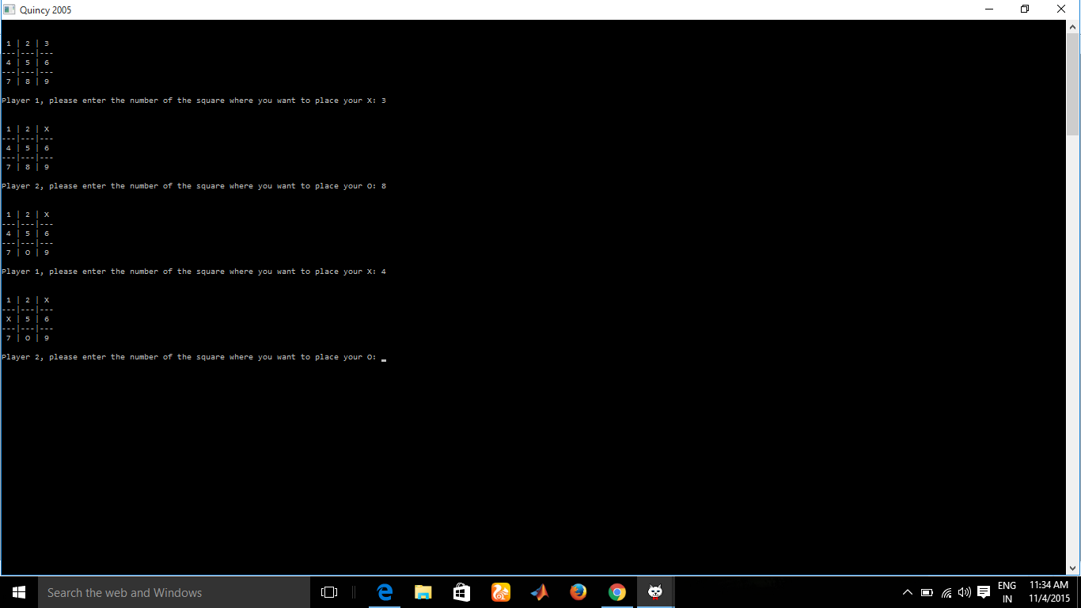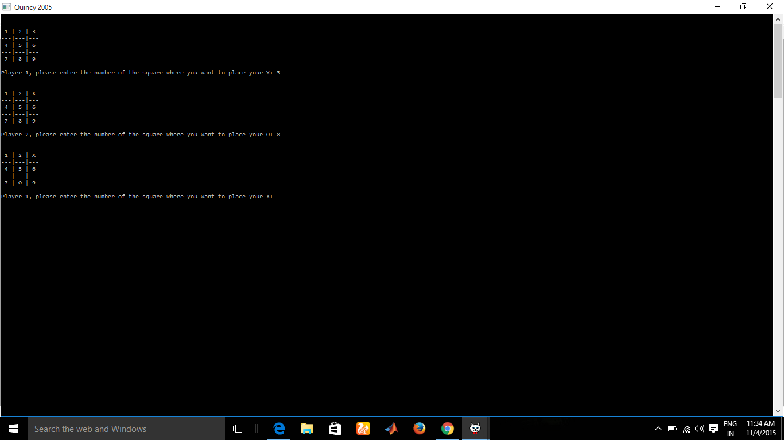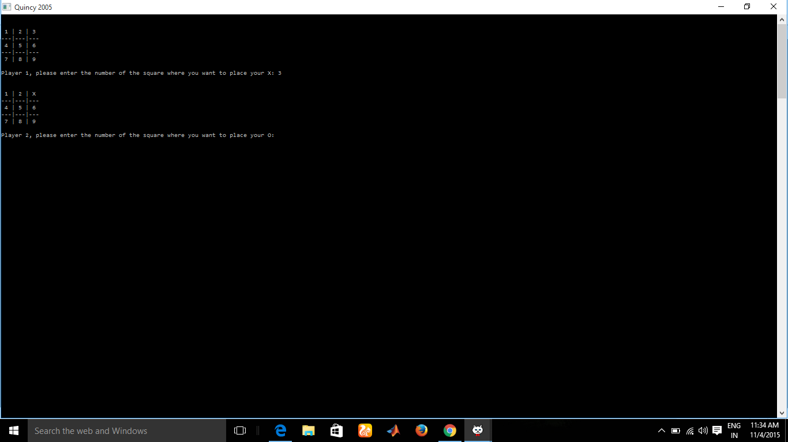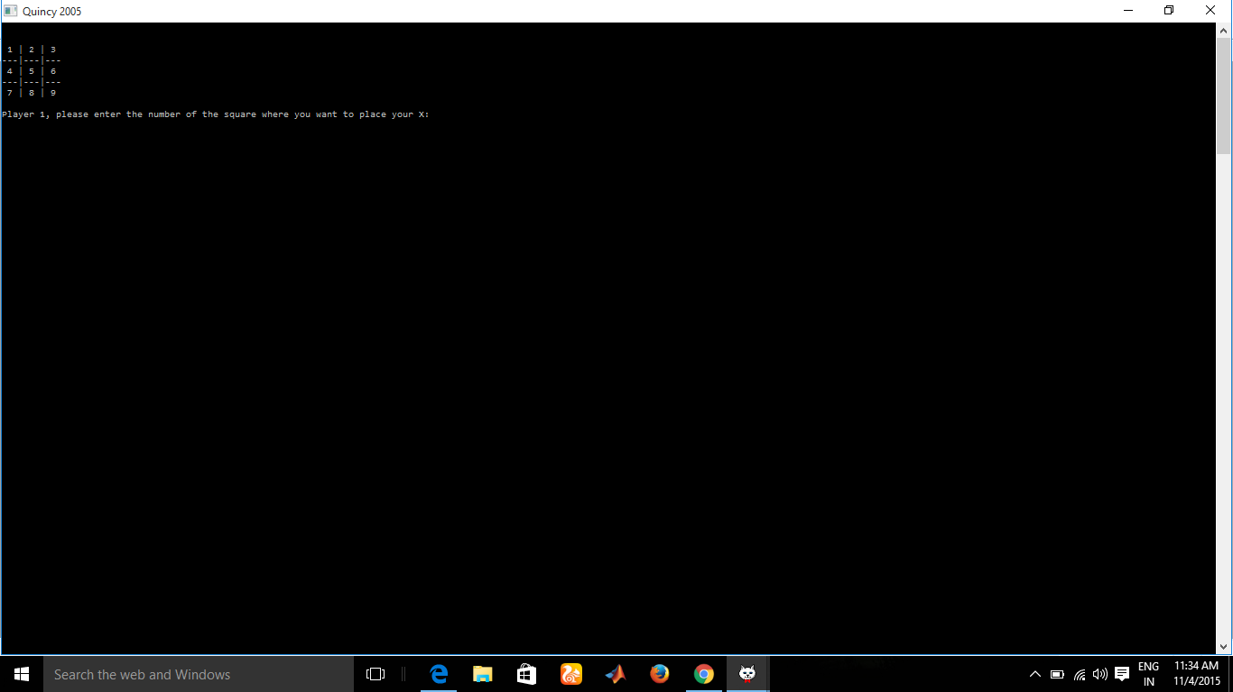

Conclusion:

We have completed our mini project by analysing the code and fixing some common errors occurring when compiling.